**Report : Social Audit of BoCW Act**

*Beawer City, Ajmer District and Bhim Block, Rajsamand District*

***I. Mandate:***

The Building and Other Construction Workers (BoCW) Act passed in 1996 was a historic legislation that heralded the recognition of the rights of construction workers to a working life of dignity and security. The Act was the outcome of a long-sustained movement of peoples’ campaigns and trade unions. Recognizing the need for the implementation of such an essential piece of legislation to meet the highest standards of efficiency, inclusivity, transparency, accountability and access, the Supreme Court (in WP (C) No. 318 of 2006 on 19th March 2018) (Annexure 1) mandated the conduct of social audits in the implementation of the Act. It stated:

“*Our fourth direction is to the Ministry of Labour and Employment, the State Governments and the UTAs to conduct a social audit on the implementation of the BOCW Act so that in future there is better and more effective and meaningful implementation of the BOCW Act. If a mistake has occurred, and we have no doubt that hundreds of mistakes have occurred in the implementation of the BOCW Act, it is more appropriate to admit the mistake for a better future rather than to justify it or continue to repeat the mistake. This is more so in the case of the BOCW Act where crores of men, women and children are involved on a day-to-day basis and Parliament has thought it appropriate to legislate for their benefit. The sanctity of laws enacted by Parliament must be acknowledged - laws are enacted for being adhered to and not for being flouted. The rule of law must be respected and along with it the human rights and dignity of building and construction workers must also be respected and acknowledged, to avoid a complete breakdown of the BOCW Act compounded by serious violations of Part III of the Constitution guaranteeing fundamental rights”*

Based on this mandate, pilot social audits were rolled out in collaboration with Civil Society Organizations (CSO) and the Ministry of Labor and Employment (MoL&E) in one ward in Delhi (Shalimar Bagh), and one block in Rajasthan (Salumbar) to arrive at a practical framework that could govern the process. The order issued by the MoL&E for the pilot audits is attached as Annexure 2. Upon arriving at the protocol for social audit that emerged through the pilots, it was shared with the MoL&E, Government of India for its consideration so that the same can be communicated to all State Governments to follow. Subsequently, the MoL&E shared this protocol in the public domain and invited public feedback before finalization (<https://labour.gov.in/sites/default/files/draft_framework_for_social_audit_on_implementation_of_BOCW_Act.pdf>).

Subsequent to the pilot social audit, the Government of Rajasthan also issued an order to set up an internal social audit cell to conduct social audits of BoCW on a regular basis. The order is attached as Annexure 3. Given the legal mandate and the past experiences with pilot social audits in rural and urban areas, it was decided to conduct further social audits in Rajasthan. Representatives of CSOs in the State had meetings with the Department of Labour and Employment, and it was decided that social audits of the implementation of the BoCW Act would be conducted in 5 Blocks, as a collaborative exercise between the Government and CSOs. It was however decided to initiate the roll out with social audits in Beawer City, Ajmer District and Bhim Block, Rajsamand District. These two locations were prioritized over the remaining three to initiate the roll out because of them being a combination of rural and urban locales, there being a high number of BoCW registered workers, there being a high amount of construction activity going on in the area and these two locations being places where daily wage labour is the most common means of earning a livelihood. The orders for the roll out are attached as Annexure 4 and 5.

The social audits that were conducted were collaborative and collective. A host of local organizations, campaigns and networks collectively participated in the social audit process as resource persons on a voluntary basis. These include: *Astha Sansthan, Aajeevika Bureau, Centre for Advocacy and Research (CFAR), CYCLE Delhi, Foundation for Ecological Security (FES), Gramin Samaj Vikas Sansthan (GSVS), Kotada Adivasi Sangthan, Jagori, Jan Jagaran Shakti Sangathan (JJSS), Mazdoor Kisan Shakti Sangathan (MKSS), National Campaign Committee for Construction Labour (NCC-CL), Rajasthan Nirman Evum General Mazdoor Union, Samata Sainik Dal, SR Abhiyan, School for Democracy (SFD), Sthai Vikas Sansthan, Social Accountability Resource Unit (SARU), Student Interns from Tata Institute for Social Sciences (TISS) Guwahati and National Law School of India University Bangalore*

***II. Social Audit Process***

Once the the State Department of Labour and Employment and CSOs had decided to collaboratively conduct social audits in two locations to begin with, and the same was recorded officially, the following were the main stages of the social audit process that followed:

1. Planning and sensitization meeting with implementing agency: (The first meeting took place on 4th September 2019, and was followed by multiple meetings)

A meeting between the State Labour Department, BoCW Board and CSO representatives took place to explain the process that would be followed in the social audit, such that it aligns to the Auditing Standards of Social Audit laid out by the C&AG Office. The site of audit, parameters of verification, information required and the formats in which they need to be provided to the social audit team, budget for expenses that would be incurred through the social audit process, responsibilities of the implementing agencies in the social audit process, public hearing participation and venue etc were discussed and finalized through these meetings. The entire Beawer City and ten Gram Panchayats[1] of Bhim Block were identified as the site of the social audit.

2. Access to information:

Information began to be provided by the implementing agency by 12th September 2019 for the selected sites. A team of CSO representative analysed the information being provided, and communicated the gaps therein. Social audits formally began in the selected locations only when information provided was complete.

3. Preliminary visits to social audit sites

A recce of the sites of the social audit were conducted between 21-25 September 2019 to understand the local context; norms of habitation spread; identify construction sites, factories, labour mandi/chowk; map out mohallas and workers living areas; potential public places where the social audit team could stay during the course of the audit. In this period a meeting with local organizations, journalists and eminent persons living in the area was also organized to understand the local socio-economic context of the area. A meeting with the representatives of the Block Office and Nagar Parishad also took place.

4. Identification of resource persons for social audit team

A call requesting for volunteers to form a part of the team that would facilitate the social audits was made to CSOs in the State and outside. Nearly 60 resource persons from National Campaign Committee for Construction Labour, Samta Sainik Dal, Aajeevika Bureau, Aastha, Foundation for Ecological Security, Grameen Samajik Vikas Sansthan, SR Abhiyan and Mazdoor Kisan Shakti Sangathan volunteered to be a part of the social audit process in Beawer City on an entirely honorary basis. The resource persons for the social audit in Bhim were students from the National Law School University of India and Tata Institute of Social Sciences, Guwahati who visited Rajasthan as a part of their academic programme.

5. Training

Trainings on records, parameters of verification, the social audit process and the code of conduct to be followed in the social audit was conducted in the School for Democracy, Rajasthan on 26-27 September 2019 and 14-15 October 2019. The agenda for the training is attached as Annexure 6.

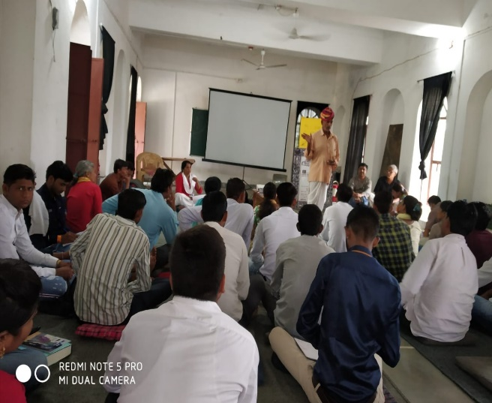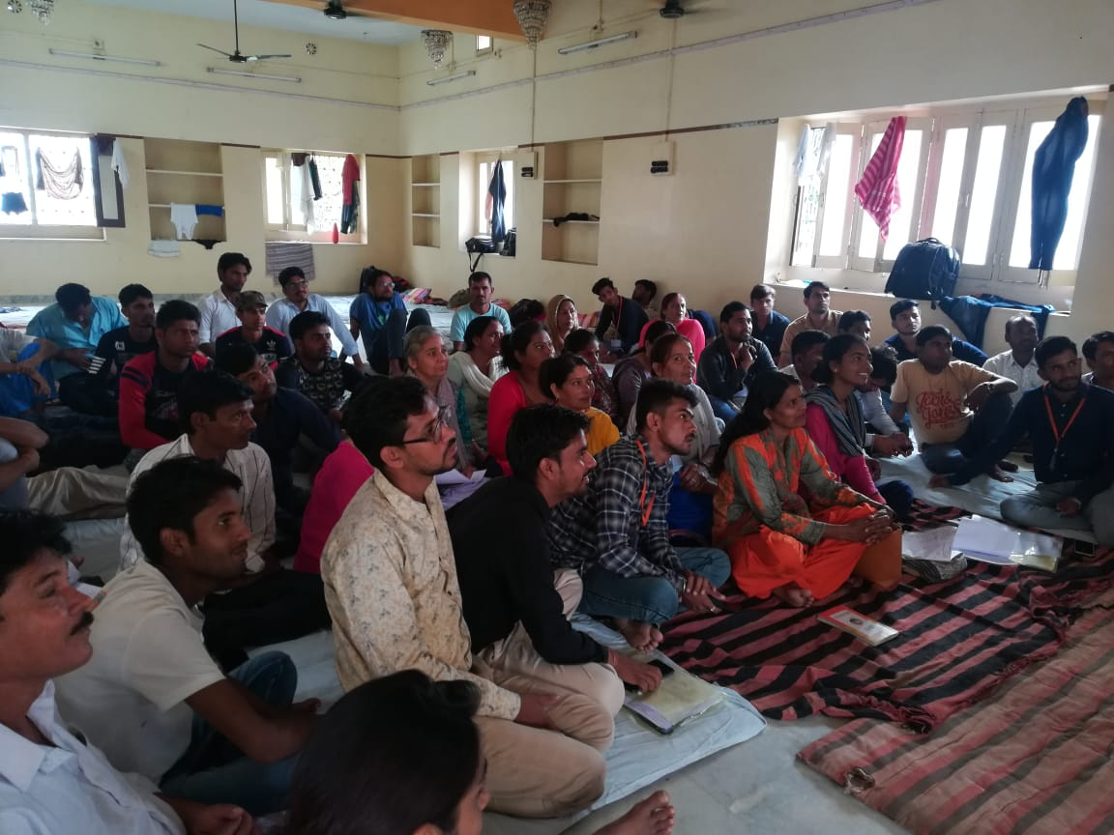

*(Training of Social Audit Resource Persons in School for Democracy, Rajasthan)*

6. Roll out of Social Audit

The Social Audit in Beawer City took place from 28 September-3 October 2019 and concluded with a Public Hearing on the 4th October 2019. The Social Audit in Bhim Block took place from 16-20 October 2019 and concluded with a Public Hearing on the 21st October 2019. The roll out began with meeting elected representatives in the area and other interested citizens. A route map was drawn out to enable the social audit team to identify how habitations were mapped across the social audit site, and therefore how the social audit teams would be divided into sub-teams. The social audit incorporated the following major activities:

* Dissemination of information regarding details of expenditure of BoCW funds and applicants to the residents of the area
* Verification of facts as stated in official records with actual reality
* Identification of those who are eligible for availing benefits under the BoCW Act but have not yet applied/are awaiting a response to their applications, and informing them of norms and entitlements
* Focus group discussions and meetings in the labour chowks (in the early morning and at night) to make people aware about their rights and entitlements under the Act

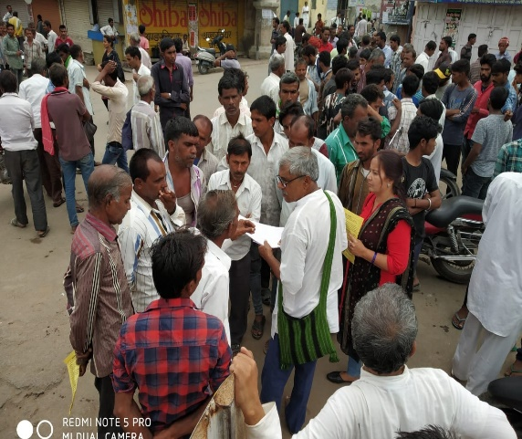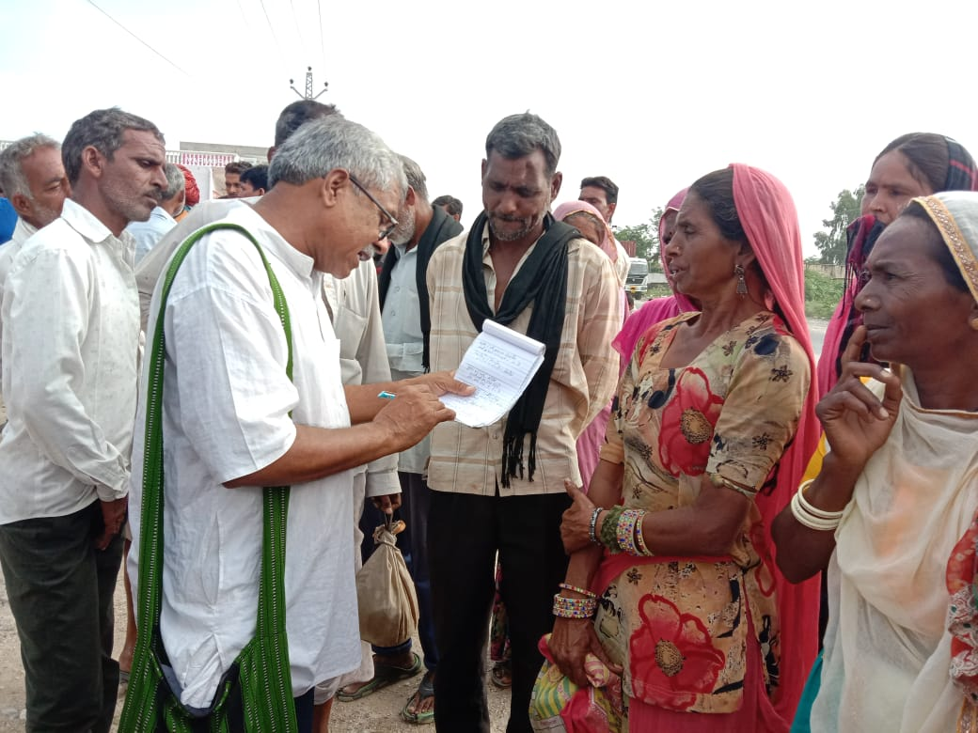

*(Verification with workers)*

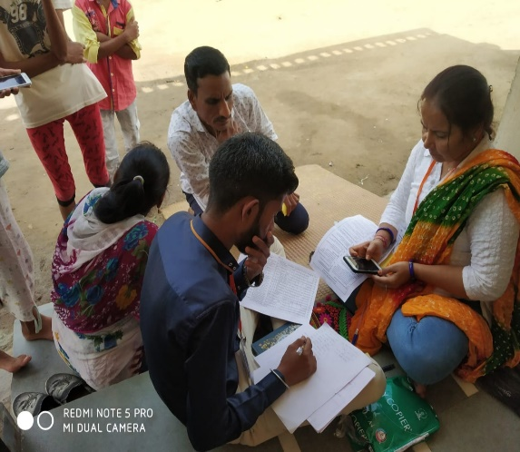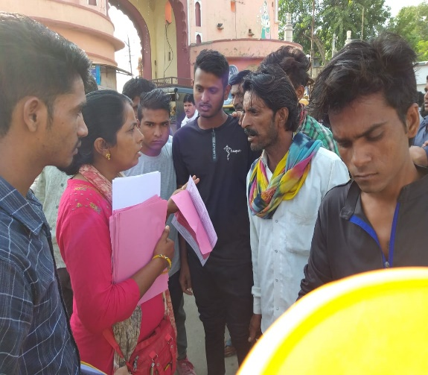

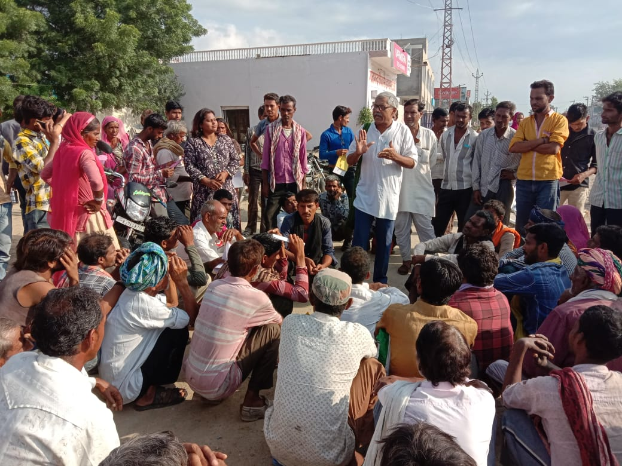

*(Sharing information with construction workers at the Labour Chowk, and verifying official records)*

A day before the public hearing, extensive efforts were made by the Social Audit team to mobilize people to attend the public hearing. A rally was organized across the main points of the city and block and songs, slogans, puppets were used to inform people of the public hearing happening the following day.

***III. Major findings***

**A substantial development that took place while the social audits were taking place in Beawer City, was that the Director General (Labour Welfare), MoL&E issued a direction to all State Governments to conduct social audits of the implementation of the BoCW Act, in pursuance of honouring the direction of the Supreme Court dated 19.03.2018. The MoL&E directed State Governments to conduct audits as per the framework that emerged from the pilot social audits in 2018. The framework communicated to State Governments via official instructions is attached as Annexure 9.**

|  |  |  |
| --- | --- | --- |
| Scope of Audit | Beawer | Bhim |
| Rural/Urban | Urban | Rural |
| Number of Wards/Gram Panchayats | 35 | 10 |
| Number of citizens who applied for BoCW registration | 9361 | 19111 |
| Number of registered BoCW workers | 6486 | 13935 |
| Number of registered BoCW Workers who applied for benefits under various schemes | 7042 | 6139 |
| Number of registered BoCW workers sanctioned benefits under various schemes | 3121 | 2767 |

Given the above scope of audit, the following were the key findings that emerged through the social audits in Beawer and Bhim:

|  |  |  |
| --- | --- | --- |
| Theme | Description | Number of cases reported (approximate figures) |
| I. Corruption | 1. Eligible workers had to allegedly pay higher than prescribed rates (Rs 40) to E-Mitras / Middlemen for applying to register with the BoCW Board.  2. Registered BoCW Workers allegedly paid higher than prescribed rates (Rs 146[2]) to E-Mitra/ Middlemen for submitting applications to avail benefits that they are eligible to get as BoCW Workers.  3. Registered BoCW Workers allegedly paid higher than prescribed rates (Rs 95[3]) to E-Mitra/ Middlemen for renewal of membership  4. An average of Rs 5000-10000 was allegedly siphoned off by E-Mitra operators/middlemen from financial benefits accrued to BoCW registered beneficiaries from various schemes, particularly Shubh Shakti Scheme.  5. Bribes were allegedly paid to Sampath Lohar, Former Labour Inspector, Beawer to process applications | Nearly 530 cases  Nearly 720 cases  Nearly 25 cases  More than 40 cases  5 written complaints |
| II. Lack of access to information | 1. No information was provided to applicants about the status of their application – whether it was accepted; whether it was pending, and if so at which level, and whether it was rejected, and if so the recorded reasons for the rejection. In the absence of any information about the status of their applications, applicants were susceptible to middlemen who would exploit this vulnerability.  2. E-Mitras and/or middlemen had privileged access to information about the status of applications made by workers, that ordinary citizens did not have. They would therefore demand bribes from the applicants with the promise that if paid they would “get the work done” ((Bhim and Beawer)  3. The correct contact details of applicants would deliberately not be entered so that they would not be informed of updates regarding their application. For instance, in Bhim, 415 out of 6139 workers had “9999999999” as their registered contact number, and 32 with “0000000000” as their registered contact numbers.  4. No proof of any Information Education and Communication (IEC) campaign undertaken by the Labour Department could be seen in the sites. No information such as rights of workers under the law, obligations of employers and labour department, processes, timelines, eligibility criteria, avenues of appeal etc was disclosed or disseminated, and no concerted effort was seen to have been undertaken by the Department to educate and inform workers about their rights under this Law (Bhim and Beawer) |  |
| III. Exploitation by E-Mitras/Middlemen and their nexus with Labour Department; Favouring of select E-Mitras | 1. Due to the lack of any direct interface between the Labour Department and citizens and there being an absence of pro-active facilitation by the Labour Department to facilitate workers in filing applications, the latter have no option but to go to E-Mitras and /or middlemen to seek help  2. 25 out of 602 operational E-Mitras were identified in Beawer for processing the maximum share of applications filed in the city. These 25 E-Mitras had a success rate of 40-60% i.e. nearly 40-60% of the applications submitted through them were successfully sanctioned. 2 out of these 25 E-Mitras had a success rate of 100%. Upon investigating these 25 E-Mitras in more detail, it was observed that applications submitted through their credentials were processed under favourable timelines by the Labour Department thereby indicating a nexus  3. Instances were identified where there was an ‘arrangement’ between certain E-Mitras, Trade Unions, individual middlemen, construction contractors and the Labour Department to certify non construction workers as construction workers so that they could avail the benefits.  4. Applications that could be traced back to select E-Mitras would get processed faster than the others. It was observed that applications for those schemes that resulted in a large amount of financial benefit were traced back to select E-Mitras. This also indicated that E-Mitras would be watching for opportunities to open with workers who live close to their area of operation, and approach them to make applications in return for a commission.  5. Out of a total 362 E-Mitras in Bhim Block, there were   * 121 E-Mitras where not even one application made by the E-Mitra for registration and benefit, was accepted/sanctioned. * 2 E-Mitras are responsible for a majority of the applications submitted and sanctioned in the Block * There were 3 E-Mitras which reported a 100% success with applications submitted and sanctioned on the same day |  |
| IV. Exclusion of eligible beneficiaries | 1. Many instances were identified where construction workers eligible for being registered with the BoCW Board and avail its benefits, were not. This was on account of the following:   * Them not being informed about this legislation and their rights within it. * Them having submitted applications, but not heard back about its status. * Them unable to get their employment history recorded so as to prove that they worked for 90 days as construction labour, as their ‘employer’ or contractor changed on a daily basis   2. It was found that invariably the actual construction workers could not *afford* the high rates of commission/bribes charged by E-Mitras and/or middlemen to process their applications.  3. Cases of inclusion of workers earning their livelihood from manual labour, but no necessarily construction work, as BoCW registered workers were observed. But it was clearly observed that such workers were *approached* deliberately by E-Mitras and/or middlemen. The latter would identify workers who reside near them and would be willing to pay a bribe/commission for availing benefits. They would then ensure falsefully that such workers are certified/verified to be construction workers. There is a deliberate misrepresentation of facts encouraged by E-Mitras and/or Middlemen which has resulted in many non-construction workers (even though the workers are poor and depend on daily labour for sustenance, but not necessarily construction work).having registered as BoCW workers. This deliberate misrepresentation was taken to its conclusion by conniving officers within the Labour Department who approved and processed such applications.  4. Due to the policy that those having BoCW registration would be considered for getting the status of Priority Household under the National Food Security Act, many workers wanting to get the latter pursued registration under BoCW even though they were not construction workers. In many such instances observed, such workers who got enrolled as BoCW workers even though they were not construction workers, did not even eventually get PHH Status under NFSA.  5. Certain workers, such as the Gadhiya Lohar Community[4] that produce building material like steel hooks were found to be living in very distressing economic and social conditions, but were not being recognized as eligible for BoCW registration by the Department. | More than 200  More than 50 such families  Nearly a 100 such families |
| V. Discrepancy | 1. Instances were identified where, as per official records the status of application for registration under BoCW was pending. But applicants had received BoCW Cards which were found to have inauthentic signatures.  2. Instances were identified where one worker had two registration IDs | Nearly 30 cases |

While the above is a summary of the key findings that emerged from the social audits that took place in Bhim and Beawer, a compilation of individual and collective findings is attached as Annexure 7 and 8.

***IV. Public Hearing and Outcomes***

The Public Hearing of the Beawer Social Audit took place on 4th October 2019. It was presided by a panel consisting of:

1. Aruna Roy, MKSS
2. Gunjan Motwani, Department of Information Technology and Communication, Government of Rajasthan
3. Harkesh Bulgariya, Secretary, Rajasthan Nirman Evum General Mazdoor Union
4. Jasmeet Singh Sandhu, Sub-Divisional Magistrate, Beawer
5. K Nitya, Probationer IAS
6. Kamla Dadgdhi, Chairperson, Nagar Parishad
7. Patanjali Bhu, Joint Secretary, BoCW Board
8. Ritupriya, Public Health Specialist
9. Suresh Sharma, Joint Labour Commissioner, Ajmer
10. SK Yadav, Labour Welfare Officer, Beawer
11. Sundaram Richard, Nirmana Mazdoor Panchayat Sangam

The following were the key decisions that were taken by the panel in response to the social audit report and evidence shared by those who participated in the public hearing:

1. An inquiry will be conducted by Labour Welfare Officer, Beawer under the supervision of Joint Labour Commissioner, Ajmer to further investigate the social audit findings and identify persons responsible for violations. The Inquiry Report will be provided within 30 days i.e. 4th November 2019.
2. Every complainant would receive a response about the action taken on their complaint, in writing
3. The Department will take measures to pro-actively disseminate information about the BoCW Act such as entitlements, norms, processes, eligibility criteria in the local area by 1st November 2019
4. An attempt will be made to lodge individual and collective complaints that emerged from the social audit as complaints on the Rajasthan Sampark Portal[5] so that the redress of such grievances can be publicly and independently tracked

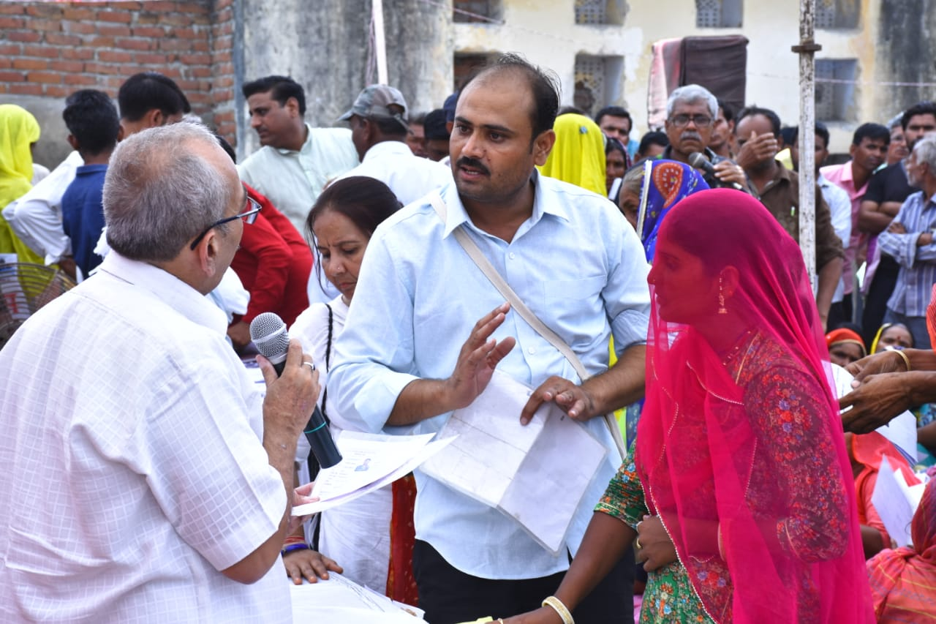

*(Social audit findings being explained to the administration in the presence of workers)*

The Public Hearing of the Bhim Social Audit took place on 21st October 2019. It was presided by a panel consisting of:

1. Abhay Kumar, Grameen Coolie Karmikar Sanghatne (GRAKOOS)
2. Anil Sharma, Legal Advisor, BoCW Board
3. Bajranglal Sharma, Former Member, Rajasthan Revenue Board
4. Dinesh Rai, Additional CEO, Zilla Parishad, Rajsamand
5. Mohit Jain, BoCW Board
6. Nikhil Dey, MKSS
7. PP Sharma, Joint Labour Commissioner, Udaipur
8. Pradeep Kumar Yadav, Labour Welfare Officer, Rajsamand
9. Ramesh Meena, BDO, Bhim
10. Samdar Singh, Deputy Superintendent of Police (DySP), Bhim
11. Sudarshan Singh, Member of Legislative Assembly (MLA), Bhim

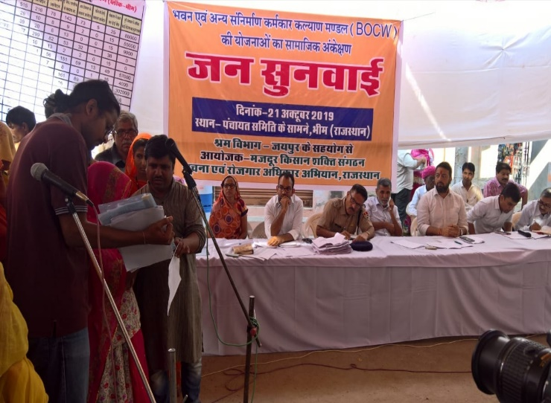

*(Social Audit team reading out the social audit findings to the panel and the public)*

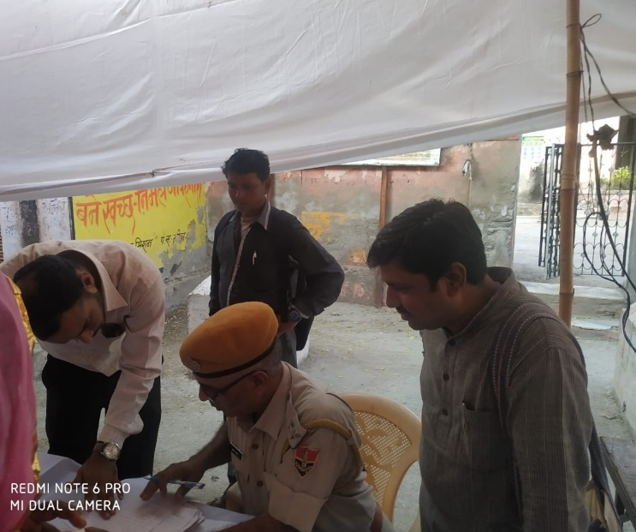

*(DySP taking cognizance of cases of corruption unearthed during the audit)*

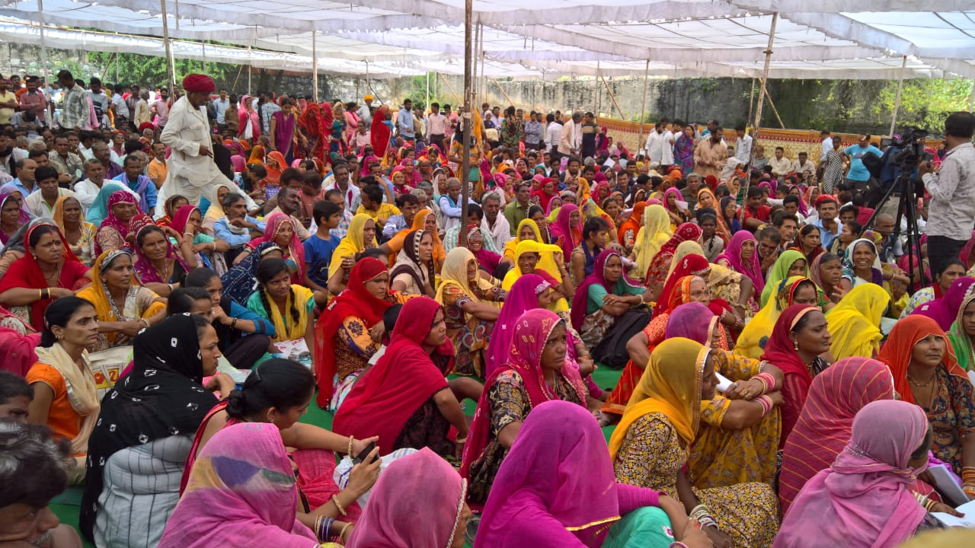

*(Participation at the Social Audit Public Hearing)*

The following were the key decisions that were taken by the panel in response to the social audit report and evidence shared by those who participated in the public hearing:

1. An inquiry will be conducted by the Labour Department to further investigate the social audit findings and identify persons responsible for violations. The Inquiry Report will be provided within 30 days i.e. 21st November 2019. When the Labour Department would conduct its inquiry, it would inform local CSOs and those who helped conduct the social audit so that they can support the process too
2. Every complainant would receive a response about the action taken on their complaint, in writing
3. First Information Reports (FIR) were registered against 16 E-Mitras and middlemen, against whom complaints were made. The FIRs were filed on the day of the public hearing itself. The DySP informed all those in the public hearing, that they should approach the Police Department even after the conclusion of the audit, to register their complaints and that they will not have to take on the burden of having to produce evidence. The DYSP stated that “he heard and watched with his ears and eyes” and has enough basis to pursue and investigate violation of entitlements

***VI. Policy recommendations***

The BOCW Act was enacted to *“regulate the employment and conditions of service of building and other construction workers and to provide for their safety, health and welfare measures and for other matters connected”* as per its Preamble. The social audit of BOCW in Bhim and Beawer, Rajasthan unfortunately exposed the multiple ways in which the letter and spirit of the Act is being violated. The social audits threw up the challenges faced by workers in accessing their legal entitlements under the BOCW Act that were to secure them a life of dignity and welfare. It also brought to surface systematic lacunae in the implementation machinery that is not restricted to the two physical areas where the audits took place. In the spirit of seeing social audits as a means of identifying procedural lapses and correct them, this report report concludes by enumerating measures that the State Government and Board must put in place for course correction and taking corrective action

I. Corrective Action

1. The State Government must immediately file FIRs against all those E-Mitra Operators, Middlemen and Government officials against whom complaints were made by workers/residents for falsely registered non-construction workers as beneficiaries under the Act, charging amounts greater than what receipts have been issued for and taking bribes to process claims of workers.
2. The State Government must file FIRs on all those Trade Unions/other private entities and take departmental action against Labour Department Officials who have falsely certified non-construction workers as BoCW registered workers
3. The State Government can identify private contractors who have certified large numbers of workers as having worked on construction related activities, and explore the possibility of charging a nominal cess from them. This can facilitate the developing of a database of such contractors, thereby facilitating greater oversight on them to prevent mass bogus certification
4. Apart from demanding an assurance from the panel that strict action should be taken against those named in complaints, within a fixed time frame, the panel was also requested to ensure that all those citizens who demonstrated courage by speaking up and voicing their grievances are not intimidated in any form

II. Institutionalize regular feedback processes

1. The State Labour Department and the State BoCW Board should conduct bi-monthly Public Dialogues (Samwaad) with civil society organizations, worker collectives, unions, workers and all those interested to participate and contribute, to get regular feedback on difficulties being faced by workers in accessing their entitlements under the Law, and implementation issues being faced the front line administration. Such dialogues should be open, and can contribute towards conception of policy solutions to systemic challenges in implementation and access.
2. In order to encourage reporting of construction activities, the BoCW Board can explore the possibility of setting up a dedicated helpline for citizens to report construction activities happening around them. Based on the calls and information received, the Board and the Department can issue notices to all those engaged in construction work to either prove that the construction expense falls under Rs 10,00,000 or pay the cess as mandated under the BoCW Act.
3. It was observed that social audits played a significant role in educating workers and providing a platform for registering their grievances. Social Audits must therefore be rolled out across the country through independent social audit units in compliance with the Auditing Standards of Social Audit.

III. Pro-active facilitation and inclusion

1. To ensure that those who are most in need of the social security cover that BoCW benefits provide are able to access it, all those workers who have completed 90 days of work under MGNREGA in the previous FY should be automatically enrolled as BoCW registered workers. This is possible on account of the digital database maintained, endorsed and certified by the Ministry of Rural Development of all those who have completed 90 days of work and therefore can be enrolled as BoCW registered workers.
2. The Labour Department should set up a Labour Information and Facilitation Centre that will provide workers relevant information, help them in filing applications and attaching the necessary documents to substantiate the same, file grievances and track them. These services should be provided free of cost
3. The Labour Department should conduct an open camp on every ‘Amavasya’, for accepting applications for registration and benefits, grievances; inform people about the status of their applications; and sharing all information related to the implementation of this Act publicly. Such camps must also be conducted at the Labour Chowks operational in the area.
4. The Department of Labour must undertake a concerted IEC campaign to educate workers about their rights under the law. Labour Chowks in the area must be mapped and IEC activities must specifically take place at such chowks. The IEC campaign must also contain dissemination about information regarding the avenues open to workers to file complaints and how to track/pursue them.
5. The Board must ensure that employers update the identity card of workers failing which penalties must be imposed on them under Section 50, BOCW Act. Labour Diary should explain entitlements and processes

IV. Transparency and Accountability mechanisms

1. To prevent corruption at the time of disbursal of benefits or sanction of renewal/registration applications, the Board should ensure distribution of sanction orders (of claims, registration and renewal) are physically distributed to workers at a public place, in the presence of workers and residents. This exercise must be undertaken on one fixed day every month.
2. To ensure that workers, E-Mitras and implementing agencies have access to the same amount of information related to multiple aspects of the implementation of this Act, all information collected and reported by the implementing agency must be publicly disclosed through offline and online modes. The Jan Soochna Portal must host information related to registered workers; sanctioned beneficiaries and benefits availed by them; citizens whose application for registration/benefits is pending and at which level; citizens whose application for registration/benefits has been rejected and the reasons behind the rejection; details of employment history on the basis of which workers are certified as BoCW registered workers; details of cess paid by construction entities and other such relevant information.

V. Deployment of additional human resource

1. The State Department of Labour should consider deploying additional functionaries at the Block Level. It was observed that owing to the Labour Office being located at the District Level, workers were unable to access and interface with the Department directly. This resulted in middlemen exploiting the vacuum. Having dedicated staff at the Block level can facilitate workers in engaging with the Department directly.

1. Bhim, Dunga ji ka gaon, Togi, Sameliya, Barar, Thikarwas, Kushalpura, Ajitgarh, Kaladeh, Kukarkheda
2. Rs 40 E-Mitra Fee + Rs 85 Labour Diary + Rs 11 GST and Service Tax + Rs 10 Printing of Card
3. Rs 25 E- Mitra Fee + Rs 60 Labour Department + Rs 10 Printing of Card + Rs 2 per month for late renewal
4. De-notified Tribe
5. Web application developed by the Government of Rajasthan through which citizens can file grievances, and track the status of their redress